**Muhammad Athar Abbas**

**SP25 - BSE - 082**

**Section A**

**Lab Assignment 3**

# Task 1:

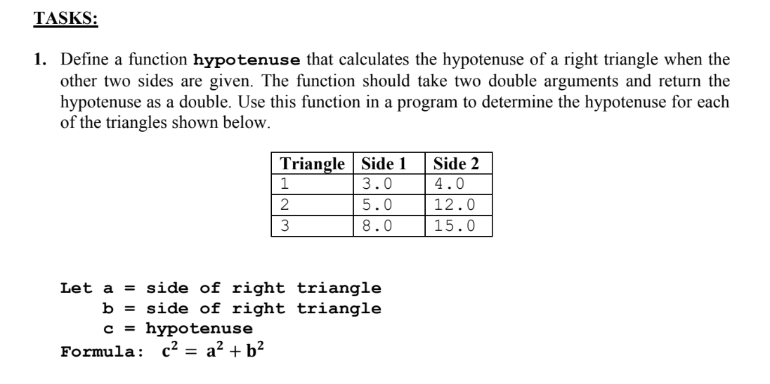

## Solution:

#include <iostream>

#include <iomanip>

#include <cmath>

using namespace std;

double hypotenuse (double side1 , double side2);

int main() {

cout << "Athar Abbas" << endl;

cout << "Sp25 - bse - 082" << endl;

cout << "Section A" << endl;

cout << setw(27) << setfill('=') << '=' << endl;

cout << "Hypotenuse Triangle 1 = " << hypotenuse(3.0 , 4.0) << endl;

cout << "Hypotenuse Triangle 2 = " << hypotenuse(5.0 , 12.0) << endl;

cout << "Hypotenuse Triangle 3 = " << hypotenuse(8.0 , 15.0) << endl;

return 0;

}

double hypotenuse(double side1 , double side2){

return sqrt(side1 * side1 + side2 * side2);

}

## Output:

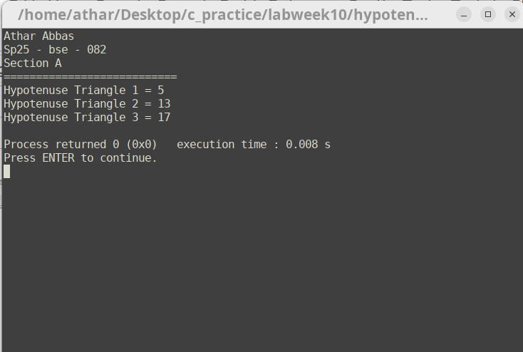

# Task 2:

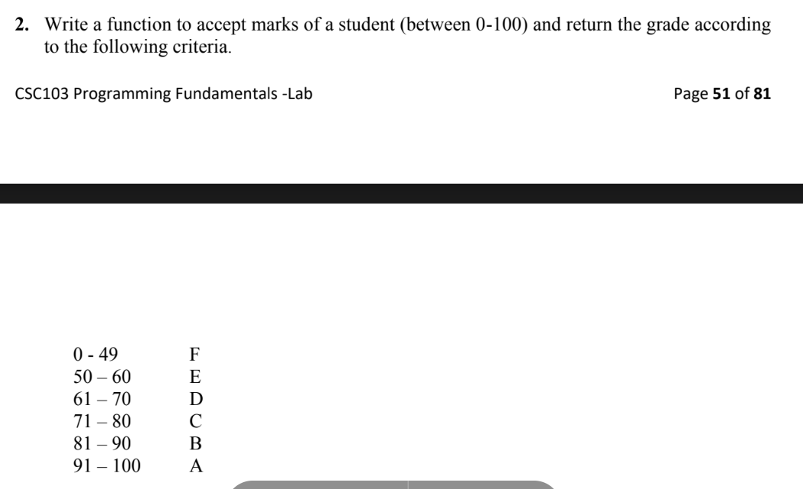

## Solution:

#include <iostream>  
#include <iomanip>  
using namespace std;  
char grade(int marks);  
int main() {  
cout << "Athar Abbas" << endl;  
cout << "Sp25 - bse - 082" << endl;  
cout << "Section A" << endl;  
cout << setw(27) << setfill('=') << '=' << endl;  
cout << "Press -1 to quit." << endl;  
int num;  
while (num != -1) {  
cout << "Input marks (0-100)" << endl;  
cin >> num;  
 while (num > 100 || num < -1) {  
 cin.clear();  
 cin.ignore();  
 cout << "Input marks (0-100)" << endl;  
 cin >> num;  
 }  
cout << grade(num) << endl;  
} ;  
return 0;  
}  
char grade(int marks) {  
  
 if (marks >= 0 && marks <= 49 ) {  
 return 'F';  
 }  
 else if (marks >= 50 && marks <= 60){  
 return 'E';  
 }  
 else if (marks >= 61 && marks <= 70) {  
 return 'D';  
 }  
 else if (marks >= 71 && marks <= 80) {  
 return 'C';  
 }  
 else if (marks >= 81 && marks <= 90) {  
 return 'B';  
 }  
 else if (marks >= 91 && marks <= 100){  
 return 'A';  
 };  
}

## Output:

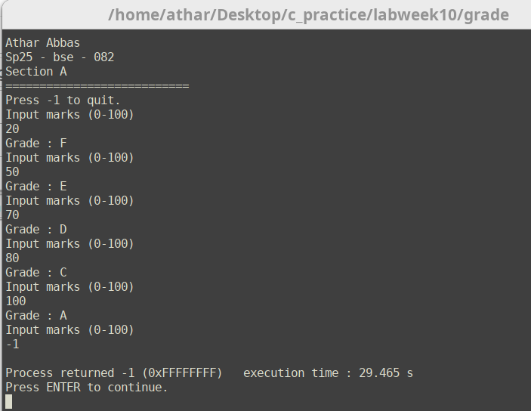

# Task 3:

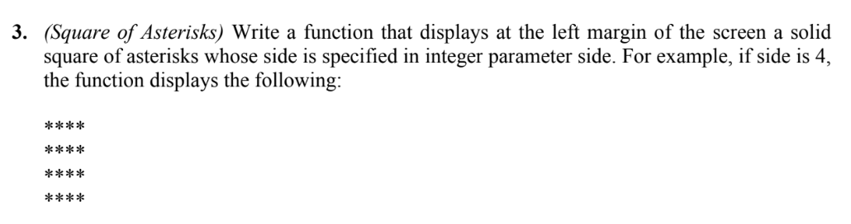

## Solution:

#include <iostream>

#include <iomanip>

using namespace std;

void asteriksquare(int num);

int main() {

cout << "Athar Abbas" << endl;

cout << "Sp25 - bse - 082" << endl;

cout << "Section A" << endl;

cout << setw(27) << setfill('=') << '=' << endl;

cout << "Press -1 to quit." << endl;

int num;

do{

cout << "Input the number for asterik square : ";

cin >> num;

cout << endl;

asteriksquare(num);

cout << endl;

} while (num != -1);

return 0;

}

void asteriksquare(int num) {

int i = 0;

int j = 0;

for (i ; i < num ; i++) {

for(j = 0; j < num ; j++) {

cout << '*';

}

cout << endl;

}

}

## Output:

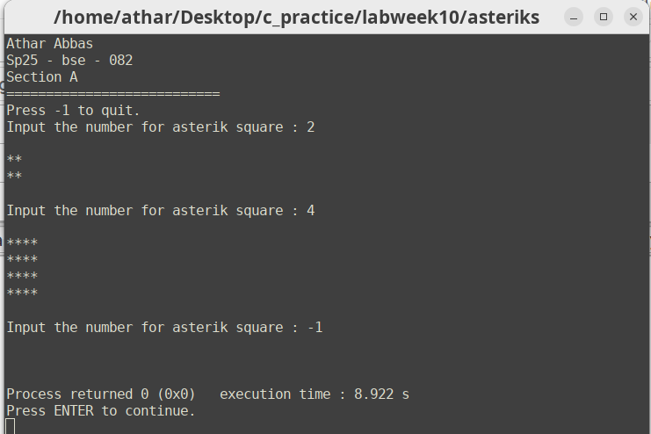

# Task 4:

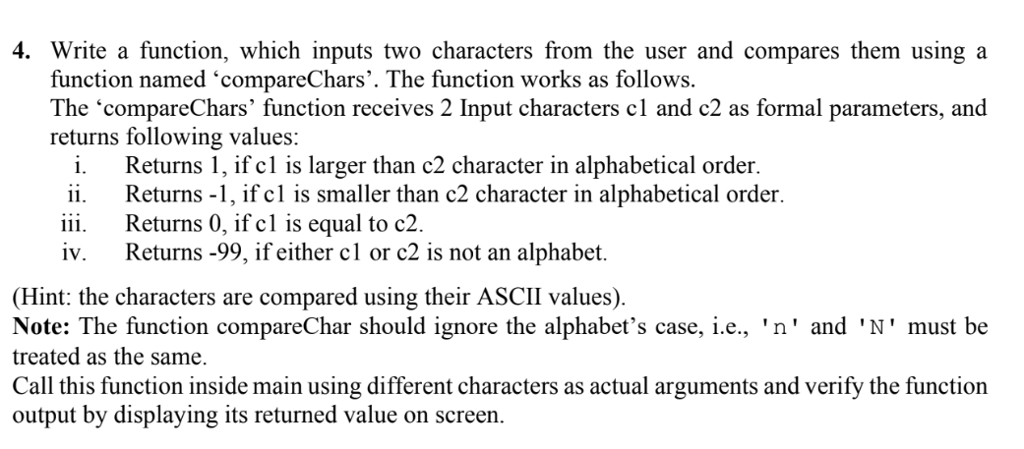

## Solution:

#include <iostream>

#include <iomanip>

using namespace std;

int comparechars(char a , char b);

int main() {

cout << "Athar Abbas" << endl;

cout << "Sp25 - bse - 082" << endl;

cout << "Section A" << endl;

cout << setw(27) << setfill('=') << '=' << endl;

cout << endl;

cout << "Press '=' to quit. " << endl << endl;

char char1;

char char2;

do{

cout << endl;

cout << "Input first character ";

cin >> char1;

cout << "Input second character ";

cin >> char2;

cout << endl;

cout << comparechars(char1,char2) << endl;

} while (char1 != '=');

return 0;

}

int comparechars(char a , char b){

if ((int(tolower(a)) < 97) || (int((tolower(a)) > 122 )) || ((int(tolower(b))) < 97 || (int(tolower(a)) > 122))){

return 99;

}

else if (tolower(a) > tolower(b)) {

return 1;

}

else if (tolower(a) == tolower(b)) {

return 0;

}

else if (tolower(b) > tolower(a)) {

return -1;

}

}

## Output:

